Importing GL Transactions
The Import GL Transactions program imports the GL entries from a text file to Aria27 and creates a new journal batch.
- To import GL Journal Transactions into ARIA:
- Open the Import GL Transactions program.

Fig (1) | 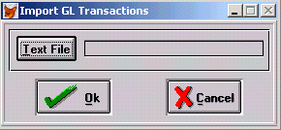
The Import GL Transaction program
- Click the Text File button to open the Windows browser.

Fig (2) | 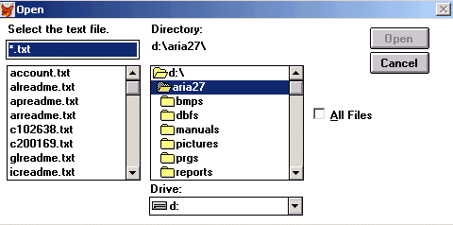
The Windows browser
- Browse and select the text file that contains the GL transactions.
- Click OK. The program automatically creates a journal batch and a message informs you of the batch number.

Fig (3) | 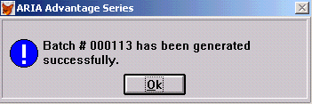
The Batch number message

NOTE | In order to view or edit the generated batch, go to the GL module / Transaction menu / the Batches option / the Journal Batch screen.

